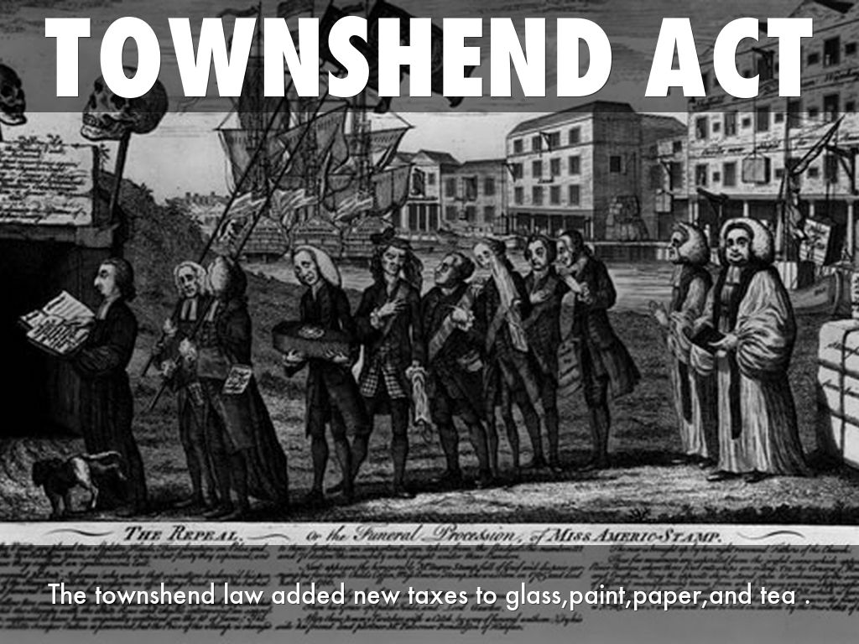

American Revolution What were the Townshend Acts?
The Townshend Acts were a series of laws passed by the British government on the American colonies in 1767. They placed new taxes and took away some freedoms from the colonists including the following:
- New taxes on imports of paper, paint, lead, glass, and tea.
- Established an American Customs Board in Boston to collect taxes.
- Set up new courts in America to prosecute smugglers (without using a local jury).
- Gave British officials the right to search colonists' houses and businesses.

How did they get their name?
The acts were introduced to the British Parliament by Charles Townshend.

Why did the British make these laws?
The British wanted to get the colonies to pay for themselves. The Townshend Acts were specifically to pay for the salaries of officials such as governors and judges.

The British thought that the colonists would be okay with taxes on imports. They had repealed an earlier tax called the Stamp Act because of colonial protests, but thought that taxes on imports would be okay. They were wrong, however, as the colonists once again protested these taxes.

Why were they important?
The Townshend Acts continued to push the American colonists towards revolution. They showed that the British didn't understand that "taxation without representation" was a really big deal to many of the colonists.

Why were the American colonists so upset?
The American colonies were not allowed any representatives in the British Parliament. They felt that it was unconstitutional for the Parliament to place taxes and laws on them without representation. It was not about the cost of the taxes, but more about the principle.

Results of the Acts
The acts caused continued unrest in the colonies. John Dickinson, who would later write the Articles of the Confederation, wrote a series of essays against the acts called Letters from a Farmer in Pennsylvania. He stated that the taxes set a dangerous precedent and, if the colonists paid them, more taxes would be coming soon. Many of the merchants in the colonies organized boycotts against British goods. They also began to smuggle in goods to avoid the taxes. Finally, protests in Boston turned violent when British soldiers panicked and killed several people in what would become known as the Boston Massacre.

Interesting Facts about the Townshend Acts
- Most of the taxes were repealed in 1770 except for the tax on tea which continued with the Tea Act of 1773.
- Charles Townshend never saw the result of his acts as he died in September of 1767.
- The Americans were not against taxes. They just wanted to pay taxes only to the local government where they were represented.
- British customs agents seized a ship owned by Boston merchant John Hancock under the new laws and accused him of smuggling. Hancock would later become a Founding Father and President of the Continental Congress.

Read more at: http://www.ducksters.com/history/american_revolution/townshend_acts.php

